The following represents the 11 weekly reports we, Team 1, have submitted to our Industry Sponsor and Academic Advisor. The reports below are presented in the original form with the respective week and date bolded for easy viewing.

Team 1 Open Source Air Quality Monitoring

**Week 1: January 2nd 2022 - January 9th 2022**

Sponsor: Dr [David Burnett](mailto:dburnett@pdx.edu)

Advisor: Dr John Acken

Team Members: [Adam Dezay](mailto:adezay@pdx.edu), [Manuel Garcia](mailto:manga2@pdx.edu), [Brandon Hippe](mailto:bhippe@pdx.edu), Mercedes Newton

**Team Review:**

* Team established meeting times.
  + Team will meet with John Acken every Monday at 4:30.
  + Team will meet independently every Tuesday at 6:35.
* Team scheduled a meeting for Monday January 16th with Dr. Burnett to discuss questions and project proposals.
* Team established a shared drive, github and trello for record keeping and collaboration.
* Team curated questions and discussed our project proposal in preparation for our first meeting with Dr. Burnett. Questions listed below:
  + What percent accuracy do we require for our CO2 sensor?
  + Should we use Eco2 to estimate CO2 or a Real CO2 sensor?
  + Can we use the other microcontroller or should we use MSP430?
* Team conducted initial research and began brainstorming potential solutions.

**Individual Review**

Adam Dezay: Agreed to create wiki for team Github.

Brandon Hippe: Began python script for component power consumption estimations.

Manuel Garcia: Conducted initial research and began weighting benefits of specific components.

Mercedes Newton: Curated team Report.

Team 1 Open Source Air Quality Monitoring

**Week 2: January 10th 2022 - January 17th 2022**

Sponsor: Dr [David Burnett](mailto:dburnett@pdx.edu)

Advisor: Dr John Acken

Team Members: [Adam Dezay](mailto:adezay@pdx.edu), [Manuel Garcia](mailto:manga2@pdx.edu), [Brandon Hippe](mailto:bhippe@pdx.edu), Mercedes Newton

**Team Review:**

* Team further curated questions and discussed our project proposal in preparation for our first meeting with Dr. Burnett. Questions listed below:
  + Size constraints? (Will affect battery life)
  + Sensor accuracy requirements, Eco2 vs Real CO2?
    - Our current constraints are that the Ec02 sensors we have looked into require extensive autocalibration and would have too long of start ups for a low power application.
  + Anemometer implementation?
    - Indoor applications will have low air speed so traditional anemometers might not make sense unless we placed it in an air duct.
  + Micro controller requirements?
    - We are currently looking at the esp32 because it has built in wifi and a deep sleep.
  + Web server preferences?
    - Current thoughts are to use a raspberry pi, running a web server, that we are able to access remotely.
  + Should we use open WSN and if so what microcontroller should be implemented?
    - Our team would prefer not to.
  + What is our budget? What will be provided by our sponsor?
    - We will require a maximum of $300 to create 1 unit, factoring varying prices and component requirements.
* Team conducted research and began brainstorming potential solutions.
* Team discussed power consumption in components
* Team developed rough draft of project proposal
* Team delegated tasks for the current week with emphasis on the project proposal and research, specific tasks are listed below.

**Individual Review**

Adam Dezay: Developing project Gantt chart, documented project in the project proposal

Manuel Garcia: Conducted initial research and began weighting benefits of specific components, assisted in documenting projects in the project proposal.

Brandon Hippe: Further developed python script for component power consumption estimations, sensor research, assisted in documenting project in the project proposal

Mercedes Newton: Curated team Report, further documented project in the project proposal

Team 1 Open Source Air Quality Monitoring

**Week 3: January 16th 2022 - January 23th 2022**

Sponsor: Dr [David Burnett](mailto:dburnett@pdx.edu)

Advisor: Dr John Acken

Team Members: [Adam Dezay](mailto:adezay@pdx.edu), [Manuel Garcia](mailto:manga2@pdx.edu), [Brandon Hippe](mailto:bhippe@pdx.edu), Mercedes Newton

**Team Review:**

This week, we met with Dr. Burnett for the first time

* After our first class meeting and meeting with our industry advisor, our team has come to the following decisions
  + We must produce 3 prototypes, with a chance of producing the initially requested 10 due to funding.
  + We shall further research and discuss how frequently our sensors take in data as informed by power requirements.
  + Spreadsheet and protocol was established for obtaining equipment from both Dr. Burnett’s lab and the EPL.
  + Team established another meeting time and workshop time.
  + Team assigned Brandon as point person and Mercedes as leader.
  + Team created a discord for communication.
* Gantt chart was revised to be more informative.
* Using a CO2 vs ECO2 sensor is still being debated.
* Team assigned each member with a sensor to specialize in.
* Team finished rough draft of project proposal
* Team delegated tasks for the current week with emphasis on the research and planning.

**Individual Review**

Adam Dezay: Created and revised gantt chart during team meeting, began CO2 sensor research

Manuel Garcia: Continued Smart mesh and kicad research

Brandon Hippe: Finished python component power analysis script. Graphs and text outputs are available on github. Started basic tests on viability of custom ultrasonic anemometer, will continue and develop final anemometer pending results.

Mercedes Newton: Reached out to faculty about HVAC system used at PSU, began PM sensor research. Organized team trello/documentation.

Team 1 Open Source Air Quality Monitoring

**Week 4: January 23rd 2022 - January 30th 2022**

Sponsor: Dr. [David Burnett](mailto:dburnett@pdx.edu)

Advisor: Dr. John Acken

Team Members: [Adam Dezay](mailto:adezay@pdx.edu), [Manuel Garcia](mailto:manga2@pdx.edu), [Brandon Hippe](mailto:bhippe@pdx.edu), Mercedes Newton

**Team Review:**

* Team submitted project proposal draft to Dr. Acken.
* Team reviewed rough draft of the project proposal and made adjustments according to the feedback from Dr. Acken.
* Team submitted rough draft of project proposal to Andrew Greenberg before our final review.
* Team received feedback from Dr. Elliott Gall in regards to HVAC systems in PSU.
* Team delegated tasks for the current week with emphasis on the research.
* Continued HVAC research and discussed the possibility of scheduling a tour with engineering building facilities, this will be a topic during our 4:30 meeting with Dr. Acken.
* Checked with EPL for parts availability, found sensors not available. How should we go about purchasing sensors? We’re currently building spreadsheet(s) with our necessary components, would we be able to send that information to Dr. Burnett for him to order?

**Individual Review**

Adam Dezay: Continued CO2 sensor research.

Manuel Garcia: Continued Smart mesh and kicad research.

Brandon Hippe: Started basic tests on viability of custom ultrasonic anemometer. Continues to develop final anemometer pending results.

Mercedes Newton: Reached out to faculty about HVAC system used at PSU, continued PM sensor research. Organized team trello/documentation.

Team 1 Open Source Air Quality Monitoring

**Week 5: January 31st 2022 - February 6th 2022**

Sponsor: Dr. [David Burnett](mailto:dburnett@pdx.edu)

Advisor: Dr. John Acken

Team Members: [Adam Dezay](mailto:adezay@pdx.edu), [Manuel Garcia](mailto:manga2@pdx.edu), [Brandon Hippe](mailto:bhippe@pdx.edu), Mercedes Newton

**Team Review:**

* Team submitted project proposal to Dr. Burnett.
* Team prepared project proposal presentation for Dr. Acken.
* Team continued prototype sensor/smartmesh development.
* Checked part availability in the EPL.

**Individual Review**

Adam Dezay: Continued CO2 sensor research. Worked on presentation.

Manuel Garcia: Continued Smart mesh and kicad research. Worked on presentation.

Brandon Hippe: Continued ultrasonic anemometer research and design. Worked on presentation.

Mercedes Newton: Continued PM sensor research. Organized team trello/documentation. Worked on presentation.

Team 1 Open Source Air Quality Monitoring

**Week 6: February 6th 2022 - February 13th 2022**

Sponsor: Dr. [David Burnett](mailto:dburnett@pdx.edu)

Advisor: Dr. John Acken

Team Members: [Adam Dezay](mailto:adezay@pdx.edu), [Manuel Garcia](mailto:manga2@pdx.edu), [Brandon Hippe](mailto:bhippe@pdx.edu), Mercedes Newton

**Team Review:**

* Conducted first team check in with professor Greenberg.
* Further solidified sensor choices, aim to order sensors during Monday meeting.
* Looked into alternate microcontrollers that would fit our application better.
* Worked on getting example code working on our MSP 430s
* Working towards getting list of components ready to purchase
* Making final tweaks to project proposal before submission by Friday noon

**Questions for moving forward**

* Can we get the template for submitting order requests so we can order components soon?
* Is there any chance of using the STM32 L series chip?
* When is our next meeting with Dr. Burnett?

**Individual Review**

Adam Dezay: Continued CO2 sensor research. Updated wiki

Manuel Garcia: Continued Smart mesh and kicad research, worked on initial MSP430/ Energia / Code Composer Studio setup, Researched other microcontrollers that may fit our application better

Brandon Hippe: Continued to develop final anemometer pending results.

Mercedes Newton: Continued PM sensor research. Organized team trello/documentation.

Team 1 Open Source Air Quality Monitoring

**Week 7: February 13th 2022 - February 20th 2022**

Sponsor: Dr. [David Burnett](mailto:dburnett@pdx.edu)

Advisor: Dr. John Acken

Team Members: [Adam Dezay](mailto:adezay@pdx.edu), [Manuel Garcia](mailto:manga2@pdx.edu), [Brandon Hippe](mailto:bhippe@pdx.edu), Mercedes Newton

**Team Review:**

* Conducted first in person team check in with Dr. Burnett.
* Solidified sensor choices.
* Worked on getting example code working on our MSP 430.
* Achieved working MSP 430/energia on ¾ team member computers.
* Created a list of components ready to purchase.
* Making final tweaks to the project proposal before submission by Monday the 20th.

**Individual Review**

Adam Dezay: Continued CO2 sensor research, decided on SGP30, worked on final project proposal, updated Wiki, Started on CO2 code, Updated final proposal.

Manuel Garcia: Continued Smart mesh and kicad research, worked on initial MSP430/ Energia / Code Composer Studio setup, assisted teammates with MSP 430.

Brandon Hippe: Continued to develop final anemometer pending results, organized ordering spreadsheet, updated proposal, assisted teammates with MSP 430.

Mercedes Newton: Continued PM sensor research, decided on SPS30. Organized team trello/documentation.

Team 1 Open Source Air Quality Monitoring

**Week 8: February 20th 2022 - February 27th 2022**

Sponsor: Dr. [David Burnett](mailto:dburnett@pdx.edu)

Advisor: Dr. John Acken

Team Members: [Adam Dezay](mailto:adezay@pdx.edu), [Manuel Garcia](mailto:manga2@pdx.edu), [Brandon Hippe](mailto:bhippe@pdx.edu), Mercedes Newton

**Team Review:**

* Worked on getting example code working on our MSP 430.
* Achieved working MSP 430/energia on ¾ team member computers.
* Enhanced gantt chart
* Submitted final project proposal
* Began parts ordering process
* Discussed potential of moving team meetings to better accommodate schedules.
* Canceled in person friday meeting due to ice and snow
* Waiting on order to arrive

**Individual Review**

Adam Dezay: Continued CO2 sensor research, decided on SGP30, worked on final project proposal, updated Wiki, Started on CO2 code, Updated final proposal.

Manuel Garcia: Continued Smart mesh and kicad research, worked on initial MSP430/ Energia / Code Composer Studio setup, assisted teammates with MSP 430.

Brandon Hippe: Continued to develop final anemometer pending results, organized ordering spreadsheet, updated proposal, assisted teammates with MSP 430.

Mercedes Newton: Continued PM sensor research, decided on SPS30. Organized team trello/documentation.

Team 1 Open Source Air Quality Monitoring

**Week 9: February 28th 2022 - March 6th 2022**

Sponsor: Dr. [David Burnett](mailto:dburnett@pdx.edu)

Advisor: Dr. John Acken

Team Members: [Adam Dezay](mailto:adezay@pdx.edu), [Manuel Garcia](mailto:manga2@pdx.edu), [Brandon Hippe](mailto:bhippe@pdx.edu), Mercedes Newton

**Team Review:**

* All 4 members have access to Energia
* Ordered and received all sensors
* Began working individually on sensors/components
  + Adam - CO2
  + Manuel - SmartMesh
  + Brandon - Anemometer
  + Mercedes - PM

**Upcoming week:**

* Have all components and sensors work independently with generic code and breadboard
* KiCAD rough draft complete

**Individual Review**

Adam Dezay: began first draft of code & circuit for CO2 sensors, updated Wik and some documentation

Manuel Garcia: Completed Energia setup for team mate, continued SmartMesh Code, KiCAD draft

Brandon Hippe: Continued Anemometer code & circuit.

Mercedes Newton: Continued PM sensor code & circuit. Organized team trello/documentation.

Team 1 Open Source Air Quality Monitoring

**Week 10: March 6th 2022 - March 12th 2022**

Sponsor: Dr. [David Burnett](mailto:dburnett@pdx.edu)

Advisor: Dr. John Acken

Team Members: [Adam Dezay](mailto:adezay@pdx.edu), [Manuel Garcia](mailto:manga2@pdx.edu), [Brandon Hippe](mailto:bhippe@pdx.edu), Mercedes Newton

**Team Review:**

* After extensive feedback from both our advisor and industry sponsor, our team has dedicated additional focus on clear documentation.
* All team members are connecting to and coding in Energia.
* Team members are each working on specified sensor/component tasks.
* Enhanced gantt chart as shown in figures 1-4.
* Moved team meetings to better accommodate schedules.
  + New times, effective immediately are Monday @ 4:30pm, Tuesday @ 7:30pm, Thursday @ 7:30pm .
* Team discussed changing meeting time with Dr. Acken for the upcoming term
  + Potential advisor meeting times that work for the team: Thursday @2-4pm or Friday at 8am, set to be discussed during Monday meeting on 3/13/2023.
  + Starting april 6, 3pm meetings.

**Individual Review**

Due to recent sponsor and advisor feedback, we have produced a more detailed description of individual progress and current roadblocks.

Adam Dezay: CO2 sensor updates - working on connecting CO2 sensors to Energia. Having issue getting I2C to work, following previous years example, yet to have success connecting using msp430 and energia. Spent around 8 hours this week troubleshooting code, finding and importing libraries, will update when progress has been made.

Manuel Garcia: Attempted to get both Smartmesh and I2C working on the MSP430. Worked more on getting specific sensors into our KiCad schematic.

SMARTMESH - able to power on a node and connect it to the host PC via coin cell power and software from analog devices. Unable to communicate with the board or power it on via power pins, Also unable to get the previous years python gui to run, suspected issues with libraries and python being different versions, need to either spend time updating code to current libraries, re-write the application to better fit our needs, or try and locate all outdated zip files of old project in order to get running. I have found that the documentation for the smartmesh system has been far less comprehensive than I was hoping for, I am not sure if I am just looking in the wrong places, however after several day long attempts I have not had success getting it to work or finding documentation on how exactly it should be set up for our purposes.

ENERGIA & MSP430 - Having issues with working with Energia and the MSP430, getting to the point where I might switch to code composer studio and re-write the whole project in C. Right now an error I get almost every time I turn on the energia IDE requires that I delete the whole “Energia15” folder from my %appdata% and reinstall it, I have not found a workaround for this. Deleting this folder has been a nuisance, however has been doable since it does not delete the code I have written. This however changes now that we are using I2C to communicate with our sensors and the smartmesh boards. I looked into how the previous year was able to use I2C and they showed how they needed to edit several files and values in the “Energia15” folder in order to get their code to run. We have not successfully re-done what they have shown because their documentation is for a different msp430 than we are using with a different pinout and chip, and the edits they made are chip specific. On Top of needing to do the work of editing these files in order to get I2C to work for our chipset, when I get this daily error requiring me to delete this subfolder I will also need to go back and make the same 20 or so code edits in order to program the IDE to work with our MSP430fr2355 chip. I also have not found good documentation on doing this online and would have to reverse engineer what last year's capstone team did and hope that with enough edits and iterations that it would work for our chip. This has led me to further consider using code composer studio because all of the official documentation from TI, as well as any other reputable source, uses code composer studio and the C language. This would require a severe overhaul of our code and take a significant amount of time to do, however I believe it would lead to more reliable and reproducible code for ourselves and any future team that was interested in continuing on with this project.

Brandon Hippe:

Anemometer updates - UART communication with both sensors is inconsistent. Each one works individually, but both don’t work simultaneously. I’ve been trying to use the same transmit pin for both so that they trigger at the same time, but I’ll have to try to get them both working separately but at the same time before trying again. Otherwise, could use the pulse duration mode, but it seemed to be very inconsistently responding to airflow.

Mercedes Newton:

PM2.5 sensor updates - Working on connecting PM2.5 sensor to Energia and producing working code. Experiencing difficulty updating sensor libraries from arduino to Energia. Currently reviewing last year’s capstone documentation and attempting to model the switch after last year’s team. Exerting new focus on documentation in order to update advisor and sponsor on team progress.

**Gantt Chart and Timeline Updates:**

Below is both the general timeline of the project as a whole as well as a breakdown of the specific tasks that are left moving forward. Due to delay in selecting and receiving sensors, as well as team difficulty in implementing them, we have postponed several of our due dates to better reflect our progress. Additionally, we have switched our gantt chart format from Excel to Google Sheets to make editing more efficient and legible. All gantt charts are representative of the timeline for this term only. In the week eleven report we intend to have an updated timeline for spring term.

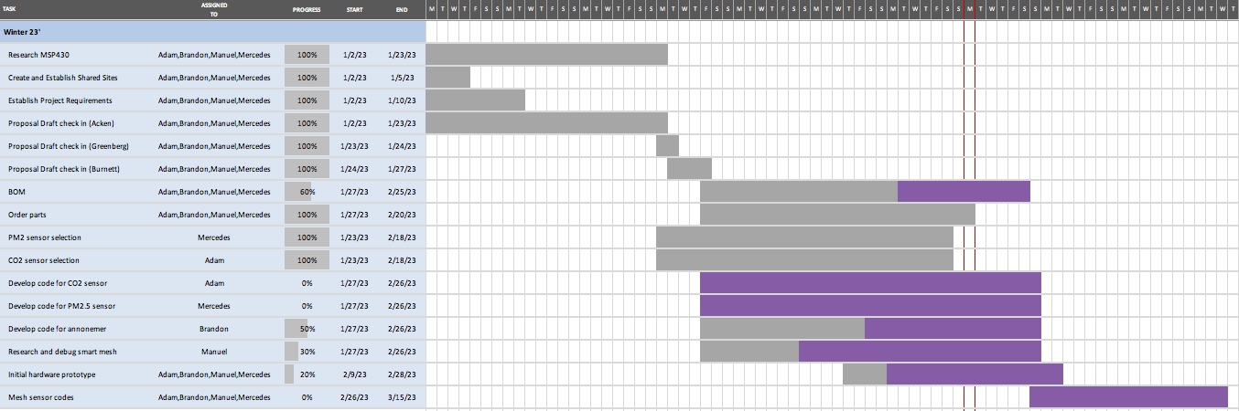

Figure 1: Original Gantt chart as seen on project proposal

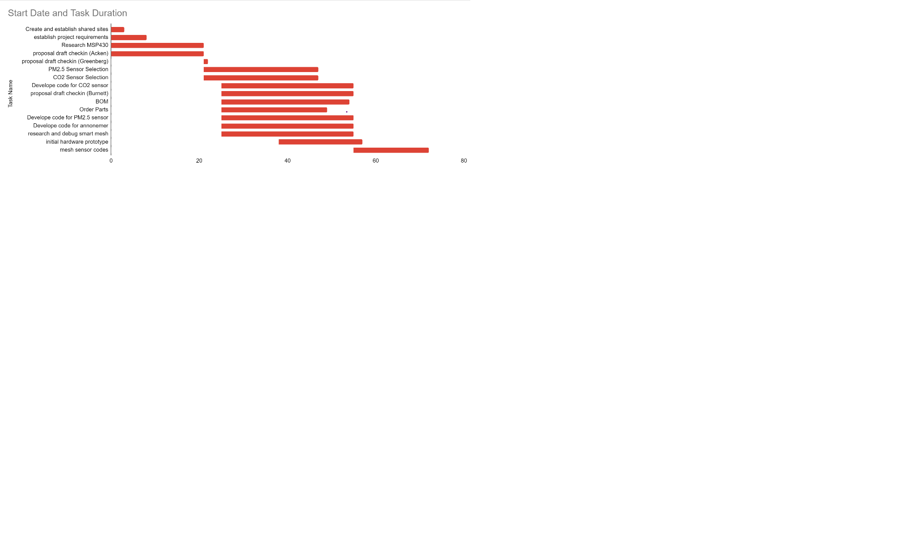

Figure two: Original gantt chart remade in Google Sheets

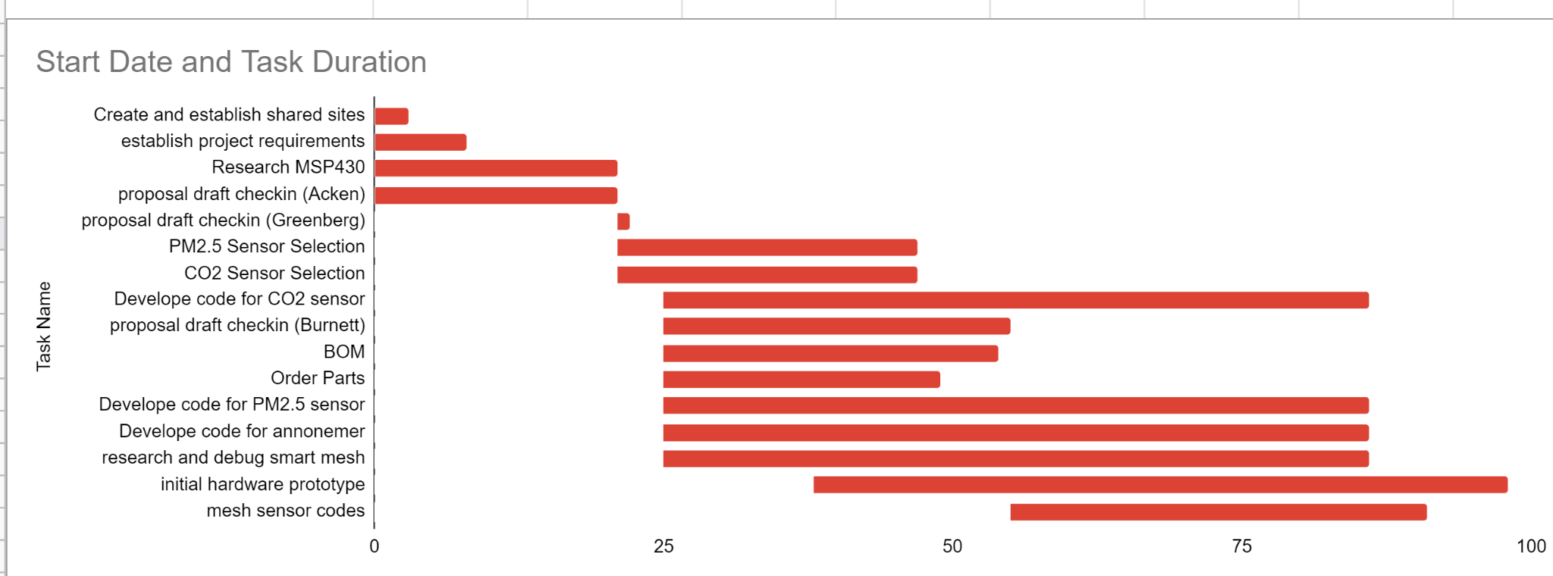

Figure three: New gantt chart with updated deadlines

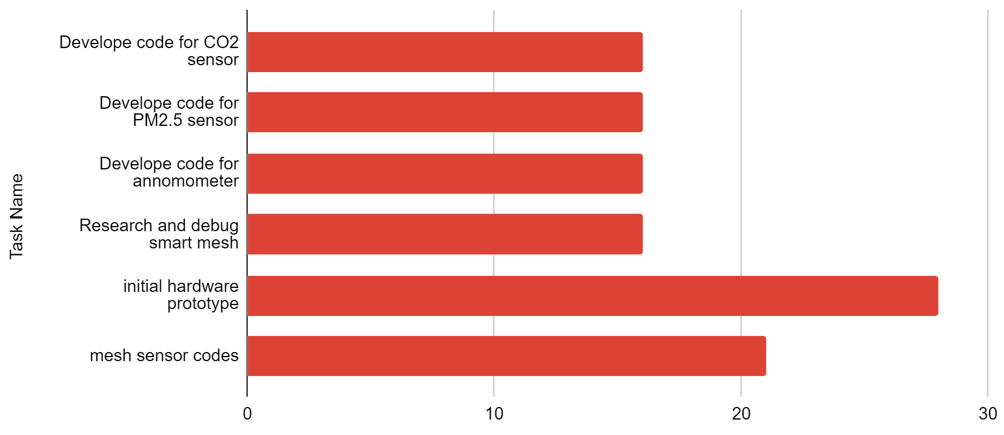

Figure four: Pending tasks with updated finishing dates in relation to current date 3/13/2023

| Task Name | Expected Completion Date |
| --- | --- |
| Develop code for CO2 sensor | 3/29/23 |
| Develop code for PM2.5 sensor | 3/29/23 |
| Develop code for anemometer | 3/29/23 |
| Research and debug smart mesh | 3/29/23 |
| initial hardware prototype | 4/10/23 |
| mesh sensor codes | 4/3/23 |

Table 1: current tasks with updated expected completion dates

**KiCad:**

Current Top-Level Kicad schematic, filling in internal subsheets with components and wires as we figure out what we need. Will post sub level schematics as we make progress in future reports.

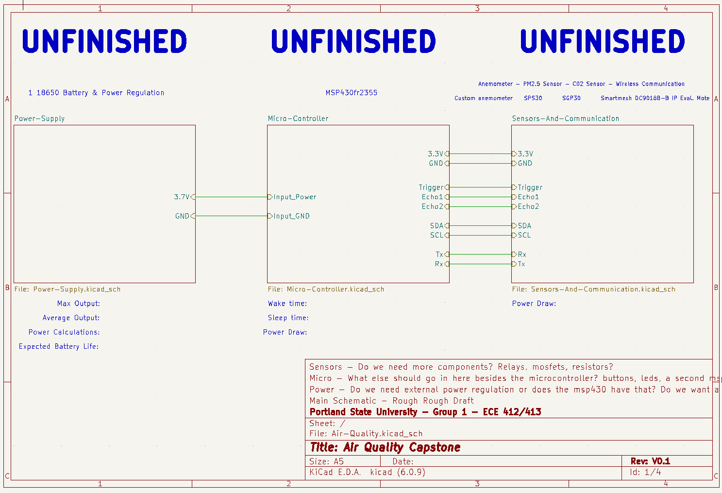

Figure Five: Top level KiCad Schematic

Team 1 Open Source Air Quality Monitoring

**Week 11: March 13th 2022 - March 19th 2022**

Sponsor: Dr. [David Burnett](mailto:dburnett@pdx.edu)

Advisor: Dr. John Acken

Team Members: [Adam Dezay](mailto:adezay@pdx.edu), [Manuel Garcia](mailto:manga2@pdx.edu), [Brandon Hippe](mailto:bhippe@pdx.edu), Mercedes Newton

**Team Review:**

* All team members are connecting to and coding in Energia.
* Team members are each working on specified sensor/component tasks.
* Enhanced gantt chart as shown in figures 1 and 2.
* Gantt chart and schedule for upcoming term (shown in figure 3).
* Moved team meetings to better accommodate schedules.
  + New times, effective immediately are Monday @ 4:30pm, Tuesday @ 7:30pm, Thursday @ 7:30pm .
* Team changed meeting time with Dr. Acken for the upcoming term.
  + Starting April 6 we will be conducting Thursday 3pm meetings.

**Individual Review**

Adam Dezay:

Worked with Brandon on getting I2C with energia working. Yet to have full success connecting with our hardware, however prospects look positive on making progress this upcoming week.

Manuel Garcia:

Did not have a chance to do a ton of work on the project this week preparing for finals. Plans in place to dedicate time to the project before the next report.

Brandon Hippe:

Anemometer updates - Still no consistent changes in ultrasonic output values with respect to wind. Planning on removing transducers from sensors and reattaching with wires to space them out and follow [this guide](https://github.com/majianjia/QingStation/blob/main/doc/anemometer.md). Also helped Adam figure out I2C communication with MSP430 in Energia, and going to start working on helping with making Energia I2C code for SPS30 and SGP30 sensors.

Mercedes Newton:

PM2.5 sensor updates - Working on connecting PM2.5 sensor to Energia and producing working code. Experiencing difficulty updating sensor libraries from arduino to Energia. Preparing for finals. Assisted team in planning for the upcoming term and created gantt chart

**Gantt Chart and Timeline Updates:**

Below is both the general timeline of the project as a whole as well as a breakdown of the specific tasks that are left moving forward. Gantt charts in figures 1 and 2 as well as table 1 are representative of the timeline for this term only. Figure 3 represents an outline of the schedule for spring term. Our team has factored in additional time for potential delays, however the current dates are subject to change. We intend to have our 3 modes built by the end of may, as displayed in our figure 3 gantt chart.

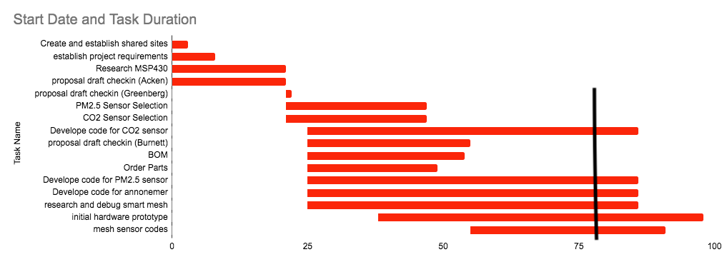

Figure One: Gantt chart with updated deadlines, black line signifies today’s date, monday 3/20/23

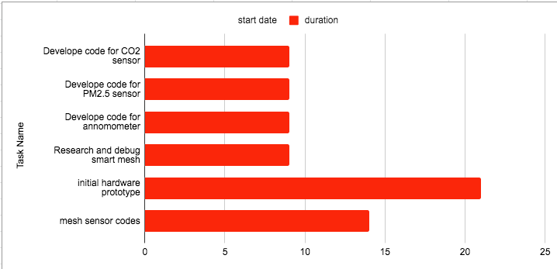

Figure Two: Pending tasks with updated finishing dates in relation to current date 3/20/2023

| Task Name | Expected Completion Date |
| --- | --- |
| Develop code for CO2 sensor | 3/29/23 |
| Develop code for PM2.5 sensor | 3/29/23 |
| Develop code for anemometer | 3/29/23 |
| Research and debug smart mesh | 3/29/23 |
| initial hardware prototype | 4/10/23 |
| mesh sensor codes | 4/3/23 |

Table 1: current tasks with updated expected completion dates

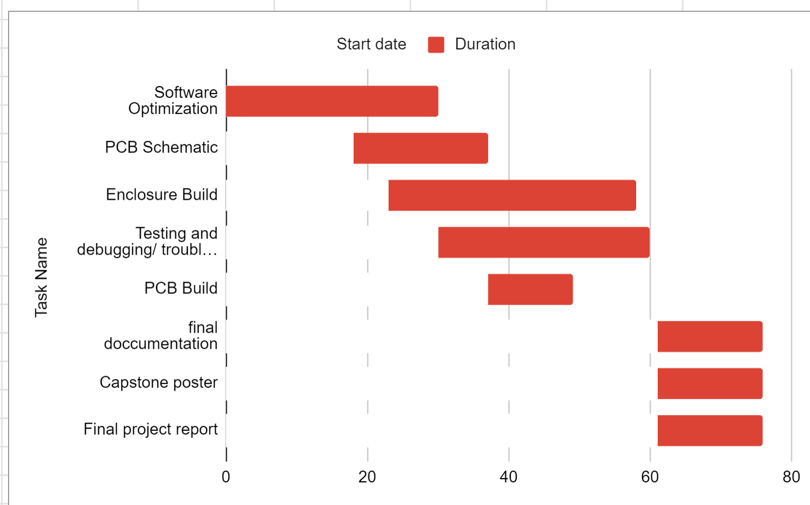

Figure three: Gantt chart for Spring term starting April 1st 2023

| Task Name | Start date | End date |
| --- | --- | --- |
| Software Optimization | 4/1/2023 | 5/1/2023 |
| PCB Schematic | 4/19/2023 | 5/8/2023 |
| Enclosure Build | 4/24/2023 | 5/29/2023 |
| Testing and debugging/ troubleshooting code | 5/1/2023 | 5/31/2023 |
| PCB Build | 5/8/2023 | 5/20/2023 |
| final documentation | 6/1/2023 | 6/16/2023 |
| Capstone poster | 6/1/2023 | 6/16/2023 |
| Final project report | 6/1/2023 | 6/16/2023 |

Table two: Tasks for spring term with expected completion dates *completion dates subject to change*